[x](http://www.mathworks.com/help/gads/ga.html" \l "outputarg_x) = ga([fitnessfcn](http://www.mathworks.com/help/gads/ga.html" \l "inputarg_fitnessfcn),[nvars](http://www.mathworks.com/help/gads/ga.html#inputarg_nvars)) finds a local unconstrained minimum, x, to the objective function, fitnessfcn. nvars is the dimension (number of design variables) of fitnessfcn.

[x](http://www.mathworks.com/help/gads/ga.html#outputarg_x) = ga([fitnessfcn](http://www.mathworks.com/help/gads/ga.html" \l "inputarg_fitnessfcn),[nvars](http://www.mathworks.com/help/gads/ga.html#inputarg_nvars),[A](http://www.mathworks.com/help/gads/ga.html#inputarg_A),[b](http://www.mathworks.com/help/gads/ga.html#inputarg_b)) finds a local minimum x to fitnessfcn, subject to the linear inequalities A\*x ≤ b. ga evaluates the matrix product A\*x as if x is transposed (A\*x').

[x](http://www.mathworks.com/help/gads/ga.html#outputarg_x) = ga([fitnessfcn](http://www.mathworks.com/help/gads/ga.html" \l "inputarg_fitnessfcn),[nvars](http://www.mathworks.com/help/gads/ga.html#inputarg_nvars),[A](http://www.mathworks.com/help/gads/ga.html#inputarg_A),[b](http://www.mathworks.com/help/gads/ga.html#inputarg_b),[Aeq](http://www.mathworks.com/help/gads/ga.html#inputarg_Aeq),[beq](http://www.mathworks.com/help/gads/ga.html#inputarg_beq)) finds a local minimum x to fitnessfcn, subject to the linear equalities Aeq\*x = beq as well as A\*x ≤ b. (Set A=[] and b=[] if no linear inequalities exist.) ga evaluates the matrix product Aeq\*x as if x is transposed (Aeq\*x').

[x](http://www.mathworks.com/help/gads/ga.html#outputarg_x) = ga([fitnessfcn](http://www.mathworks.com/help/gads/ga.html" \l "inputarg_fitnessfcn),[nvars](http://www.mathworks.com/help/gads/ga.html#inputarg_nvars),[A](http://www.mathworks.com/help/gads/ga.html#inputarg_A),[b](http://www.mathworks.com/help/gads/ga.html#inputarg_b),[Aeq](http://www.mathworks.com/help/gads/ga.html#inputarg_Aeq),[beq](http://www.mathworks.com/help/gads/ga.html#inputarg_beq),[LB](http://www.mathworks.com/help/gads/ga.html#inputarg_LB),[UB](http://www.mathworks.com/help/gads/ga.html#inputarg_UB)) defines a set of lower and upper bounds on the design variables, x, so that a solution is found in the range LB ≤ x ≤ UB. (Set Aeq=[] and beq=[] if no linear equalities exist.)

[x](http://www.mathworks.com/help/gads/ga.html#outputarg_x) = ga([fitnessfcn](http://www.mathworks.com/help/gads/ga.html" \l "inputarg_fitnessfcn),[nvars](http://www.mathworks.com/help/gads/ga.html#inputarg_nvars),[A](http://www.mathworks.com/help/gads/ga.html#inputarg_A),[b](http://www.mathworks.com/help/gads/ga.html#inputarg_b),[Aeq](http://www.mathworks.com/help/gads/ga.html#inputarg_Aeq),[beq](http://www.mathworks.com/help/gads/ga.html#inputarg_beq),[LB](http://www.mathworks.com/help/gads/ga.html#inputarg_LB),[UB](http://www.mathworks.com/help/gads/ga.html#inputarg_UB),[nonlcon](http://www.mathworks.com/help/gads/ga.html#inputarg_nonlcon)) subjects the minimization to the constraints defined in nonlcon. The function nonlcon accepts x and returns vectors C and Ceq, representing the nonlinear inequalities and equalities respectively. ga minimizes the fitnessfcn such that C(x) ≤ 0 and Ceq(x) = 0. (Set LB=[] and UB=[] if no bounds exist.)

[x](http://www.mathworks.com/help/gads/ga.html#outputarg_x) = ga([fitnessfcn](http://www.mathworks.com/help/gads/ga.html" \l "inputarg_fitnessfcn),[nvars](http://www.mathworks.com/help/gads/ga.html#inputarg_nvars),[A](http://www.mathworks.com/help/gads/ga.html#inputarg_A),[b](http://www.mathworks.com/help/gads/ga.html#inputarg_b),[Aeq](http://www.mathworks.com/help/gads/ga.html#inputarg_Aeq),[beq](http://www.mathworks.com/help/gads/ga.html#inputarg_beq),[LB](http://www.mathworks.com/help/gads/ga.html#inputarg_LB),[UB](http://www.mathworks.com/help/gads/ga.html#inputarg_UB),[nonlcon](http://www.mathworks.com/help/gads/ga.html#inputarg_nonlcon),[options](http://www.mathworks.com/help/gads/ga.html#inputarg_options)) minimizes with the default optimization parameters replaced by values in the structure options, which can be created using the [gaoptimset](http://www.mathworks.com/help/gads/gaoptimset.html) function. (Set nonlcon=[] if no nonlinear constraints exist.)

[x](http://www.mathworks.com/help/gads/ga.html#outputarg_x) = ga([fitnessfcn](http://www.mathworks.com/help/gads/ga.html" \l "inputarg_fitnessfcn),[nvars](http://www.mathworks.com/help/gads/ga.html#inputarg_nvars),[A](http://www.mathworks.com/help/gads/ga.html#inputarg_A),[b](http://www.mathworks.com/help/gads/ga.html#inputarg_b),[],[],[LB](http://www.mathworks.com/help/gads/ga.html" \l "inputarg_LB),[UB](http://www.mathworks.com/help/gads/ga.html#inputarg_UB),[nonlcon](http://www.mathworks.com/help/gads/ga.html#inputarg_nonlcon),[IntCon](http://www.mathworks.com/help/gads/ga.html#inputarg_IntCon)) requires that the variables listed in IntCon take integer values.

[x](http://www.mathworks.com/help/gads/ga.html#outputarg_x) = ga([fitnessfcn](http://www.mathworks.com/help/gads/ga.html" \l "inputarg_fitnessfcn),[nvars](http://www.mathworks.com/help/gads/ga.html#inputarg_nvars),[A](http://www.mathworks.com/help/gads/ga.html#inputarg_A),[b](http://www.mathworks.com/help/gads/ga.html#inputarg_b),[Aeq](http://www.mathworks.com/help/gads/ga.html#inputarg_Aeq),[beq](http://www.mathworks.com/help/gads/ga.html#inputarg_beq)) finds a local minimum x to fitnessfcn, subject to the linear equalities Aeq\*x = beq as well as A\*x ≤ b. (Set A=[] and b=[] if no linear inequalities exist.) ga evaluates the matrix product Aeq\*x as if x is transposed (Aeq\*x').

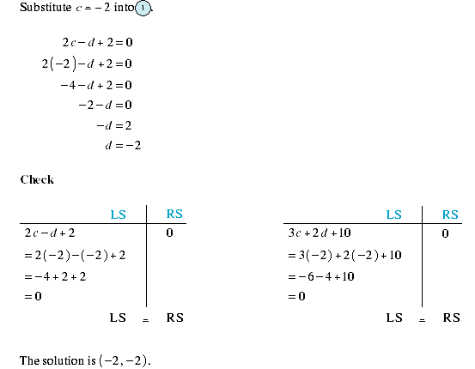  
  
This would imply that a linear inequality is a Boolean argument.